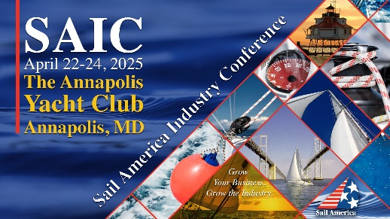

**2025 Sail America Industry Conference- Frequently Asked Questions**

1. **Who should attend?**

SAIC is *the* place for sailing industry professionals to learn about new topics and trends, receive updates, and network with over 100 participants. The conference features a group activity (regatta or golf), a day and a half of educational sessions, an industry dinner, networking opportunities and more.

1. **Registration deadlines info…**

The registration fee for the conference is $395 for members and $495 for non-members. Please register in advance. On-site registration is also available.

1. **What is the cancellation policy for the conference registration fee?**

While we hope you don’t have to cancel, we understand that conflicts do arise. Please contact conference staff. Please note that once the orders have been placed with the venue, we can no longer refund your registration.

1. **How do I book a hotel reservation?**

**Annapolis Waterfront Hotel, Autograph Collection-Courtesy Room Block:** [**Book your group rate for Sail America 2025 Conference Room Block.**](https://protect.checkpoint.com/v2/r01/___https:/www.marriott.com/event-reservations/reservation-link.mi?id=1734964941067&key=GRP&guestreslink2=true&app=resvlink___.YzJ1OmhobWhvdGVsczpjOmc6OWNkY2M4ZjIxMDg1ZmQyOWEzMGI1NjEyZWYyMjE5NGU6NzozYWM4OjU2ZmYyZmVlOGNkMDlhYjZmNzNjY2Y1MDIzMDI5NTVmOGZiN2ExMmQ4OGI5ZjY4NjYyNGJlOTM3YTg0Y2YzMzE6aDpUOk4) **The courtesy block has a limited number of rooms available. If the block is sold out, please contact Sail America staff.**

1. **Will I get to go sailing?**

One of the best parts of SAIC is the group activity – historically sailing! We will host a regatta on Tuesday, April 22 at 1:00PM at the Annapolis Sailing School. Register on the website as an individual or a team.

1. **I need meeting space for my company during SAIC, is this possible?**

Yes, please contact Stephanie Grove at [sgrove@sailamerica.com](mailto:sgrove@sailamerica.com). Several Sail America members are hosting meetings in conjunction with the conference and the hotel is eager and able to work with you directly to coordinate your specific meeting needs.

1. **What airport is the closest? Will there be shuttles?**

Three nearby international airports provide easy access to Annapolis & Anne Arundel County: [**Baltimore-Washington International Thurgood Marshall Airport**](http://visitannapolis.org/plan/listings/689) (BWI). [**Ronald Reagan Washington National Airport**](http://www.visitannapolis.org/plan/listings/1242) (DCA), and [**Washington Dulles International Airport**](http://www.visitannapolis.org/plan/listings/1243) (IAD). The airports provide a host of ground transportation options including rental cars, shuttles and public transportation.

|  |  |
| --- | --- |
|  |  |

1. **I’d like to sponsor SAIC, how do I do that?**

Wonderful, we’d love to talk to you about Sponsorship Opportunities! Please visit the Sponsorship tab of the conference website for additional information. Please contact Stephanie Grove at [sgrove@sailamerica.com](mailto:sgrove@sailamerica.com) with any questions or to discuss. Thank you!

1. **Who are the contacts at Sail America for this event?**

SAIC Meeting Planner: Stephanie Grove ([sgrove@sailamerica.com](mailto:sgrove@sailamerica.com))

SAIC Meeting Planner: Michelle Umberger ([mumberger@sailamerica.com](mailto:mumberger@sailamerica.com))

1. **Do I need to be a member of Sail America to attend?**

Sail America members enjoy a $100 discount on conference registration. As a Sail America member, you will enjoy this discount and more! Please take a minute to review the [Membership Brochure](http://www.sailamerica.com/membership/) and email/call Stephanie Grove ([sgrove@sailamerica.com](mailto:sgrove@sailamerica.com)) if you’d like to join!

1. **What meals are included in my registration fee?**

Continental Breakfast each day

Snack/Coffee Breaks

Opening Reception-Light fare

Reception & Raffle-Light fare

1. **Is parking at Hotel Annapolis free?**

Only AYC members with current AYC parking stickers may park at AYC. Street parking is available in Annapolis, plus there are private parking lots and garages.  Eastport Elementary School plans to allow parking on their field across from AYC’s Sailing Center for a daily fee.