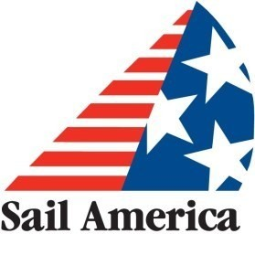

Build your business now:
Understanding and responding to today’s (good-news) boating trends

Sail America is pleased to offer the industry an on-line event that will help members understand today’s boating trends and how to respond to them. Featuring two notable speakers – Jack Ellis of Infolink and Marcus Sheridan of Marcus Sheridan International, Inc.—and contributions from leading industry experts on questions that are key to your business’s future.

Tuesday, October 6, 2020 9am-12noon ET Location: Zoom platform

Agenda

9:00 am Welcome & Introductions- Freya Olsen, NMMA

9:15 A Changing U.S. Boat Market: A peek into the future– Jack Ellis, President and Founder of InfoLink

9:45 Facilitated Questions & Answers with Jack

10:00 Going Virtual: How to Evolve Your Digital Sales and Marketing to Meet the
Demands of Today’s Buyer, with Questions & Answers - Marcus Sheridan 11:30 Industry roundtable – How are industry leaders responding?
Noon Thank you and adjourn

